More Guided Notes
Algebra I ELL
System of Equations-Graphing

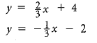
1)

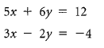
2)

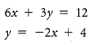
3)

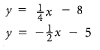
Assignment:
