3.2 Linear Functions
You Try (Examples 1-3)
Refer to Example 1 if you need help
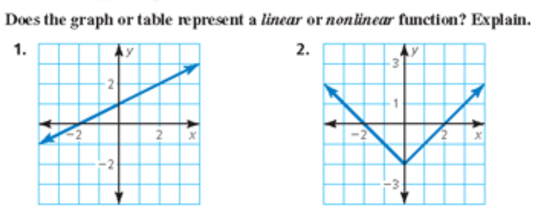

Refer to Example 2 if you need help
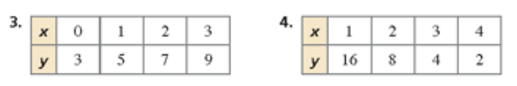

Refer to Example 3 if you need help
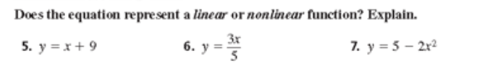

3.2 Linear Functions
You Try (Examples 4 & 5)

Refer to Example 4 if you need help
8) The linear function $m=50-9d$ represents the amount m (in dollars) of money you have after buying d DVDs.
a) Find the domain of the function. Is the domain discrete or continuous?

b) Graph the function using its domain.

Refer to Example 5 if you need help
9) Is the domain discrete or continuous? Explain?
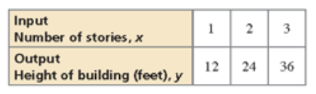

10) A 20-gallon bathtub is draining at a rate of 2.5 gallons per minute. The number g represents the gallons remaining is a function of the number m of minutes.
a) Does this situation represent a linear function? Explain.

b) Find the domain of the function. Is the domain discrete or continuous? Explain.

c) Graph the function using its domain.

