Pre-Calculus
Max/Min Value Problems

- Find the length and width of a rectangle that has a perimeter of 80 meters and a maximum area,
- An open box of max volume is to be made from a square piece of material, 24 inches on a side, by cutting equal squares from the corners and turning up the sides. What is the maximum volume of the box?
- Find two positive numbers such that the sum of the first number and twice the second number is 108, and the product is a maximum.
- Find the length and width of a rectangle that has an area of 32 square feet and a minimum perimeter.
- Use the diagram to determine on the graph of $y=4-x^{2}$ which points are closest to the point $(0, 2)$
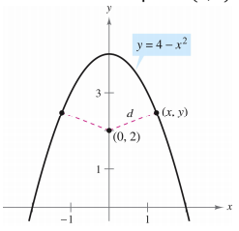
- A farmer plans to fence a rectangular pasture adjacent to the river. The pasture must contain 245,000 square meters in order to provide enough grass for the herd. What dimensions will require the least amount of fencing if no fencing is needed along the river?
- A rectangular package to be sent by a postal service can have a minimum combined length and girth (perimeter of cross section) of 108 inches. Find the dimensions of the package of maximum volume that can be sent.

